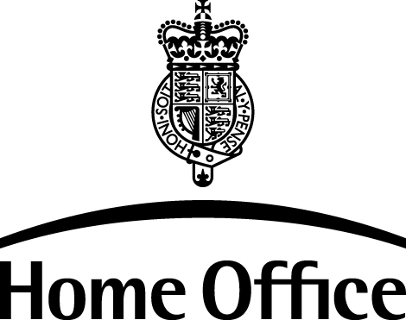

Drugs Legislation and Enforcement Unit, 6th Floor Peel Building, 2 Marsham Street, London SW1P 4DF
Direct Line: 020 7035 0472 Fax: 020 7035 6161 licensing_enquiry.aadu@homeoffice.gsi.gov.uk

APPLICATION FOR PERSONAL IMPORT/EXPORT LICENCE
- Please delete Import or Export above as appropriate
- Please complete ALL FIELDS, giving details of CONTROLLED DRUGS ONLY
- Please send/fax the completed form to Drugs Licensing Unit: 020 7035 6161
- The form must be accompanied by a brief note from the appropriate doctor/addictions service, on headed notepaper, confirming that the details given are correct
- Please note that faxed licences are not usually accepted by customs
- Please allow 2 WEEKS for the application to be processed

PATIENT DETAILS
Title
First Name (as in passport)
Surname (as in passport)
Current Address

Postcode
Country of Destination
Departure Date
Return Date

DETAILS OF DRUG(S)
 | Name (brand or chemical) | Form (eg tablets  /ampoules/  mixture) | Strength of preparation  NOT DOSAGE | Total quantity to be taken abroad  (In mgs)
Drug 1
Drug 2
Drug 3
Drug 4

DETAILS OF DOCTOR/NURSE/DRUGWORKER WHO MAY BE CONTACTED FOR FURTHER INFORMATION:
Name
Telephone/Fax/Email

LICENCE TO BE POSTED TO: (IF NOT TO PATIENT AT ABOVE ADDRESS):
c/o Name
Address
Postcode

Unless you request otherwise, the Licence once issued will be sent by post to the patient at the given address. Please not faxed licences are not valid.

